KARNATAK LAW SOCIETY’S

GOGTE INSTITUTE OF TECHNOLOGY

UDYAMBAG, BELAGAVI-590008

(An Autonomous Institution under Visvesvaraya Technological University, Belagavi)

**(APPROVED BY AICTE, NEW DELHI)**



*Course Activity report*

*on*

***Free Ping Tool and its Implementation***

*Submitted in the partial fulfillment for the academic requirement of*

***5th Semester B.E.***

***in***

***Computer Science Engineering***

***Submitted by***

Aditya Nandeshwar

Aniketh Mahadik

Atreay Kukanur

Fakkiresh Noorshetter

**GUIDE**

*Prof.P Khangoudra*

**2021 – 2022**

Karnataka Law Society’s

GOGTE INSTITUTE OF TECHNOLOGY

Udyambag Belagavi -590008

Karnataka, India.

**Department of Computer Science and Engineering**



**Certificate**

This is to certify that the Course seminar report work titled **“*Free Ping Tool and its Implementation* ”**  carried out by Aditya Nandeshwar**,** Aniketh Mahadik, Atreay Kukanur, Fakkiresh Noorshetter bearing **USNs:** 2GI19CS008,2GI19CS019, 2GI19CS028, 2GI19CS041is submittedin partial fulfilment of the requirements for 5th semester B.E. in **Computer Science and Engineering,** Visvesvaraya Technological University, Belagavi. It is certified that all corrections/ suggestions indicated have been incorporated in the report. The course project report has been approved as it satisfies the academic requirements prescribed for the said degree.

Date: Signature of Guide

Place: Belagavi Guide Name

***Prof. P Khangoudra***

KLS Gogte Institute Technology, Belagavi

Name of the Examiners Signature of the Examiners

1.___________________ 1.____________________

2.____________________ 2.____________________

**Title: *Free Ping Tool and its Implementation***

**Team Members Details:**

|  |  |  |
| --- | --- | --- |
| **S. No.** | **USN** | **Student Name** |
| 1 | 2GI19CS008 | Aditya Nandeshwar |
| 2 | 2GI19CS019 | Aniketh Mahadik |
| 3 | 2GI19CS028 | Atreay Kukanur |
| 4 | 2GI19CS041 | Fakkiresh Noorshetter |

**Marks Allocation:**

|  |  |  |  |  |  |  |
| --- | --- | --- | --- | --- | --- | --- |
|  | **Batch No.: 11** | | | | | |
| 1. | Seminar Title: | Marks Range | **USN** | | | |
| **2GI19CS008** | **2GI9CS019** | **2GI19CS028** | **2GI19CS041** |
| 2. | Abstract (PO2) | 0-2 |  |  |  |  |
| 3. | Application of the topic to the course (PO2) | 0-3 |  |  |  |  |
| 4. | Literature survey and its findings (PO2) | 0-4 |  |  |  |  |
| 5. | Methodology, Results and Conclusion  (PO1, PO3, PO4) | 0-6 |  |  |  |  |
| 6. | Report and Oral presentation skill (PO9, PO10) | 0-5 |  |  |  |  |
|  | Total | 20 |  |  |  |  |

**Signature of Staff:**

**Table of Contents**

**OVERVIEW................................................................................................................**

**FEATURES................................................................................................................**

**IMPLEMENTATION..................................................................................................**

**SYSTEM REQUIREMENTS.....................................................................................**

**CONCLUSION…………………………………………………………………………….**

**REFERENCES………………………………………………………………………………**

**OVERVIEW:**

**Free Ping Tool**

In the complex network environment, various severs and devices such as routers, switches are need to be up and running all the time . Any outages of these servers and devices will affect the performance of the network usage and eventually, it will affect many users. Similarly, you cannot leave your website availability to chance, more so in today's internet economy where most businesses depend on their websites for revenue.

Therefore, it is highly imperative that you monitor your internal servers and devices in LAN environment and also web sites externally at all times so that you become aware of problems early enough before it translates into substantial loss of revenue.

The ManageEngine "Free Ping Tool" will address this monitoring requirement. The ManageEngine Ping Tool, using ICMP Ping, monitors the availability of servers, routers, switches and mail servers internally and more importantly websites externally. The tool fetches important parameter like Round trip time, Time to Live of the packet, presents them as visually elegant running graphs and reports. The relevant data, graphs and reports are displayed in a desktop tool dashboard providing wealth of information about the real time functioning of the servers and websites.

The ManageEngine "Free Ping Tool" can monitor 10 servers and websites simultaneously.

The best part is that the tool is made available, absolutely FREE of cost.

**Monitor the servers, devices and websites using ManageEngine Free Ping Tool**

**Free Ping**

ManageEngine Free Ping Tool provides an exclusive monitoring of server, switch, router and websites as a desktop tool dashboard. It shows the actual round trip time of servers internally and also for the external websites.

In case of non-availability of servers then alert signal are shown in the dashboard. If at all, server goes down or non-availability of server due to other network problem or response time increases alarmingly than the desired level. The IT administrator can then effortlessly manage instances to prevent server crash, or bring back the servers to normal functioning state.

**Free TraceRoute**

The traceroute helps to find the full trace path of the server⁄host internally and

externally. Tool also shows Round trip time, Number of hops it takes to reach remote destination. These parameter are presented in a neat graphical view.

The ManageEngine Free Ping Tool serves as a smart desktop tool that continuously monitors servers across your network and also external websites for their availability and gives traceroute, giving you simple yet real-time network monitoring solution.

**DNS Lookup**

The DNS Lookup tool retrieves domain name records for the domain name that you provide. You can use this to help diagnose problems and see if the problem originates from the domain name server — if you cannot return a domain’s records, you’ll know where to begin troubleshooting!

Fetch the DNS records of websites

Get the different types of DNS records of websites,viz., SOA, A, MX, NS and Text

**Web Responses**

Ping works by sending an **Internet Control Message Protocol (ICMP) Echo Request**to a specified interface on the network and, in return, sends out replies to validate the connection.

The **ping response** is the most important thing to keep an eye on when performing a ping test.  Knowing what each response means will help and guide you identify the right troubleshooting path.

Below are the top responses that you commonly see when pinging.

• **Reply from** – When you see this response from the address that you pinged, it means that your connection is good.  Take note of the time of replies you're receiving.  The more replies you get, the better your connection is with the router.

• **Request Timed Out**– The ping command timed out because there was no reply from the host or the destination host is down.

• **Unknown Host**– This response means that your computer cannot recognize the IP address that you are trying to ping.  Usually, this error message will recommend the user to check the spelling of the host name.

• **Destination Network / Host unreachable**– This means that the host that you are trying to ping is down or is not operating on the network.

• **Hardware Error** – This usually means that your network adapter is disabled or you have unplugged the Ethernet cable.

**HTTP Performance Monitoring**

Keep a tab on the performance of your websites

Get a graphical view of TCP connection time, redirection time and response time of websites

Set the optimum refresh interval (10 seconds by default)

**Features:**

**Free Ping Tool**

The ManageEngine Free Ping tools helps the administrators to monitor the availability servers, devices and websites continuously and ensures that these servers, devices are running properly in real-time environment using the ICMP ping request.

• Monitor servers and devices using ping

• Graph Details

• Email, Save Option

• Retain Setting

• TraceRoute

**Monitor servers and devices**

ManageEngine Free Ping Tool helps an administrator to view the following parameters and gives the availability of the server and its response time in real-time

**1. Monitor Status of the servers, devices and websites**

ManageEngine Free Ping Tool sends ICMP ping request to the server and if the target destination is reachable and if the server sends the ping response back then availability of the host is ensured then tool will show the status of the server as UP. If the tool is unable to reach the target host using ping command then it will state the status as DOWN.

**2. Ping Success Count**

Tool pings the server, devices at specified time interval if remote host sends back the ping reply, Ping successful reply count will be incremented by one. Number of successful pings counts are shown here.

**3. Ping Failure Count**

Similar to success count, Tool will send PING request to the servers and devices. If the server or devices did not respond back then the server is not running or may be due to network related problem the packet is dropped. Then failure count will be incremented by one.

**4. Host IPAddress**

The ability to ping an IP address of remote host is vital to network troubleshooting. Ping Tool utilizes the ICMP ECHO protocol and sends a packet to a specified destination. It is called an ECHO_REQUEST. If the target destination is reachable, remote host will generate an ECHO_REPLY and sends it back to Ping Tool. When the ECHO_REPLY is received, connectivity between two hosts on a network is verified and the IpAddress is received.

**5. RoundTripTime [ms]**

Round-trip time (RTT), also called round-trip delay, is the time required for a signal pulse or packet to travel from a specific source to a specific destination and back again.

On the internet, an end user can determine the RTT to and from an IP (Internet

Protocol) address by sending ping requests to that address. Tool displays the RTT value in table and graph.

**6. TimeToLive (Ttl) [Secs]**

Time-to-live (TTL) is a value in an Internet Protocol (IP) packet that tells a network router whether or not the packet has been in the network too long and should be discarded. The original idea of TTL was that it should specify a certain time span in seconds that, when exhausted, would cause the packet to be discarded. Tool shows the value of Ttl in table. Graph Details

The ManageEngine Free ping tool give the round trip time in a intuitive moving real time graph. Graph is drawn with Number of instances in the X-axis versus RoundTripTime(ms) in Y-axis for multiple hosts. The graph is drawn over the specified refresh time Intervals.

**Email, Save Option**

• Administrator can send email from this tool about the snap shots of the ping ,

Traceroute details to all stake holders.

• Take snap shot of Ping data details, Ping data graph , trace route details of the

servers.

**Retain Setting:**

Ipaddress ⁄ Host name entered is stored internally and while starting the tool next time, Administrator need not enter the all the Ipaddress again. Tool will populate data for all the Ipaddress automatically.

**Implementation :**

**Introduction**

The ManageEngine FREE Ping tool is a simple yet powerful tool with an elegant UI that helps to issue ping requests to "Multiple IP Addresses" in a single instance. And can find the health of the sever continuously for a maximum of 10 hosts. The ping data such as Ipaddress, RoundTripTime, Time To Live (Ttl), Buffer Size and the status are shown in a table.

**Add remote hosts to monitor**

The user can enter either a HostName or the IPAddress of the remote host in the

Addressfield. Multiple IP Addresses / Hostnames can be added by either clicking the Add button or pressing the "Enter" Key in the Address field. The ping tool monitors a maximum of 10 hosts . This will populate the host details in the ping tool table. Later, Ping tool will send ping requests to every host to be monitored after clicking the start button.

**Start the tool**

After entering all the hostnames or IPAddress in a table then click Start button. When the start button is clicked all the ping data values will be populated in table at a the specified refresh interval.

**Stop the tool**

The "Stop" button helps the user to stop issuing ping requests to all the populated hosts.

Clear

The user can clear the data available in the table as well as in the graph, by clicking 'clear'. To clear the data and the graph, the user has to stop the ping and then click clear icon.

**Refresh Interval**

By default the refresh interval will be set to 5 minutes. The user can modify the refresh interval according to the need.

**Refresh Now**

The user can refresh the data available in the table by clicking refresh button this will refresh the table and graph.

**Status Icons**

• Grey Icon : when the user adds a hostname to the table, a grey icon will be

displayed which shows the status of the remote host as "Unknown".

• Green Icon : When tool receives the ping response then the tool will show the

"Green Icon". It shows the status of the remote host as “Success”.

• Red Icon : Failure to receive ping response then the tool will show the "Red Icon".

It shows the status as "Failure".

**Table**

Collected ping data will be populated in a table.

• **Delete a row** : User can delete a row by clicking the delete icon displayed at the end of the row. To delete the remote host, user has to stop the ping tool then

click the delete icon.

• **Sorting the columns** : The user can sort the columns by clicking the "Sort" icon available in the table header.

• **Help** : The user can access help by clicking the help icon available at the top right corner of the Ping Tool.

**Email, Save Option**

**Email Settings Properties :**

The Email Settings properties allow you to specify where emails will be sent.

• **MailServer Details**: The MailServer property includes both "Server Name

• **Email** : The "Email" field indicates which email address should receive form data when a user submits form.

• **From** : The "From" property indicates which email address should be filled in for the From address.

• **User Name & PassWord** : The UserName & Password should be given to

provide the access to the user to send emails.

**Attachments :**

• The Attachment allows the users to add files to your message. If attachments is not required, user can skip this section.

• **MaxAttachments** : The maximum attachments allowed in email settings screen is 5 Files.

**Save Option :**

The save option enables the user to "Save" the Ping Data, Ping Graph and Trace details as bit map in application bin directory. All the data will be saved based on date & time.

• **PingData** : The ping data will be saved as "pingdata_2010-12-6-14-43-49.png".

• **PingGraph** : The ping graph will be saved as "pinggraph_2010-12-7-11-57-

5.png".

• **TraceGraph** : The trace page will be saved as "tracedetails_gmail.com_2010-12-7-11-58-1.png" along with the hostname.

**ScreenShots:**

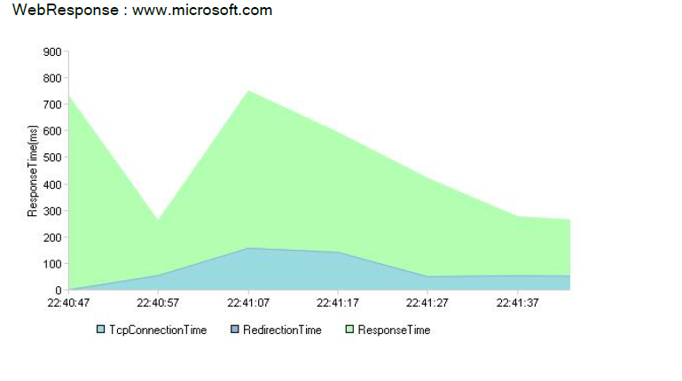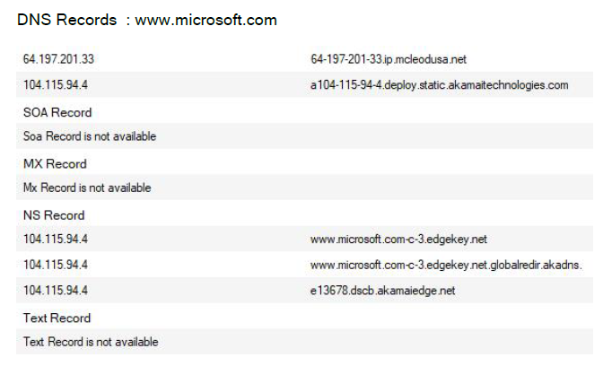

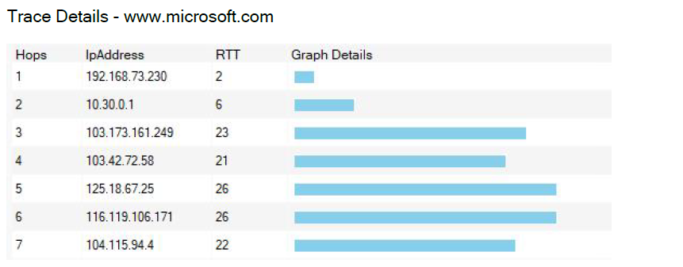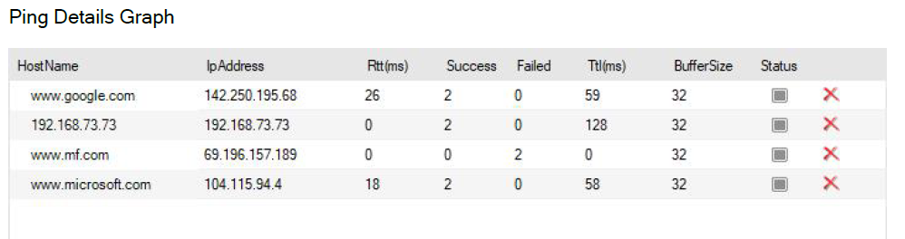

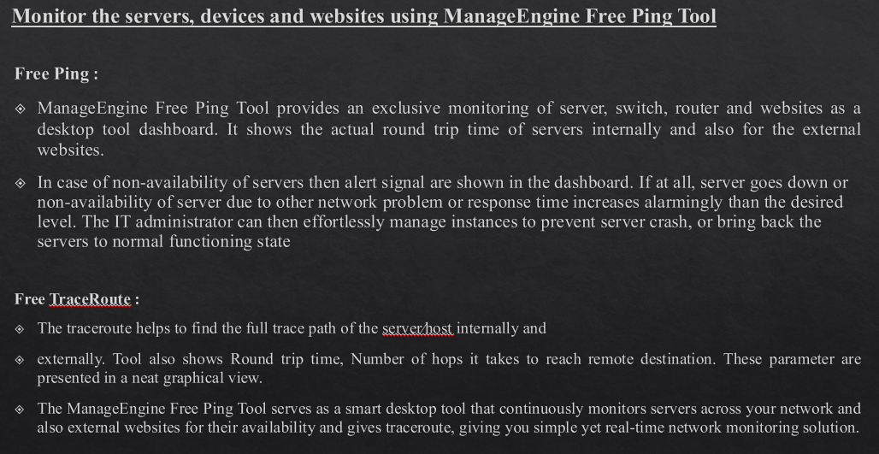

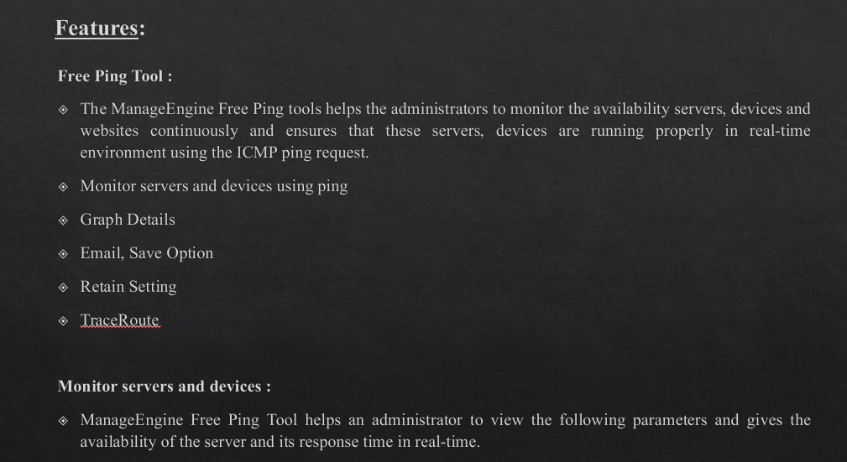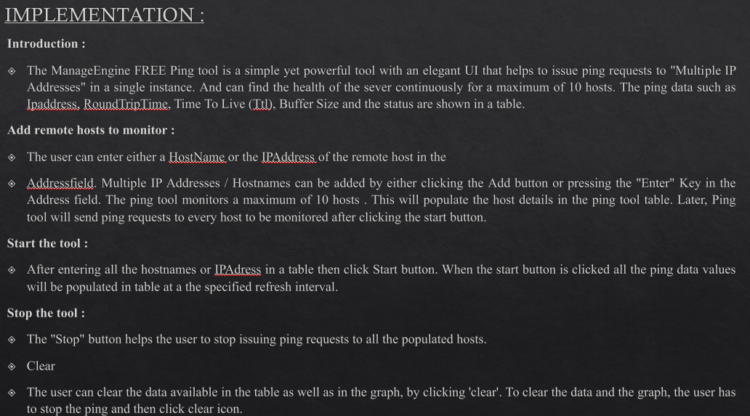

**System Requirements:**

**Hardware**

• Atleast 3 MB of Disk space before installation.

• Less than 10 MB of Disk space after installation.

• Atleast 512 MB RAM.

**Software**

• Microsoft Windows Operating Systems eg. Windows XP, Windows Vista, Windows 2003 & Windows 7.

• Microsoft .Net Framework 2.0 / 3.0 / 3.5.

**Conclusion:**

IT professionals need to know when their critical servers and network appliances are running smoothly, and even more importantly, when they go offline.

A ping utility is especially useful for this purpose, as it keeps a constant stream of ping requests going to your important network devices.

Using a ping monitoring application to keep track of how things are running is also very efficient on your overall network capacity, which means that you can keep the services running indefinitely without affecting the performance of your network or internet connection.

**References:**

* https://www.manageengine.com/free-ping-tool/free-ping-tool-index.html
* James F Kurose and Keith W Ross, Computer Networking, A Top-Down Approach, Sixth edition, Pearson,2017 .
* Behrouz A Forouzan, Data and Communications and Networking, Fifth Edition, McGraw Hill, Indian Edition.
* Larry L Peterson and Brusce S Davie, Computer Networks, fifth edition, ELSEVIER.
* Andrew S Tanenbaum, Computer Networks, fifth edition, Pearson.
* Mayank Dave, Computer Networks, Second edition, Cengage Learning.